Lab 1

1-



2-



3-



4-

rm - for removing files



rmdir – for removing directory



5-



6-

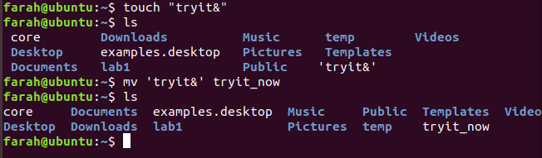

7-

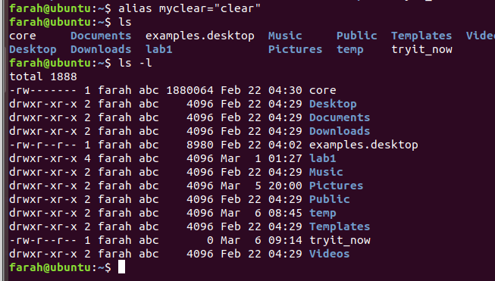

8-

a)

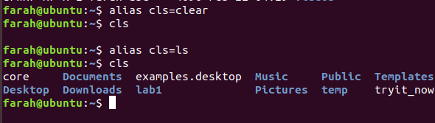

b)

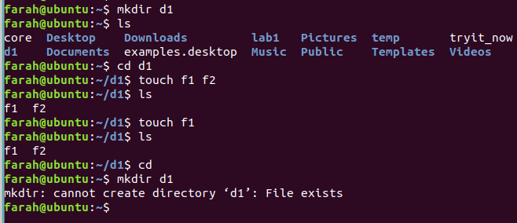

9-

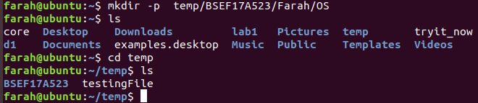

10-

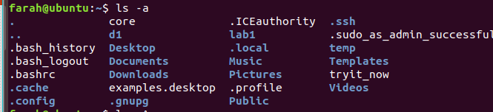

11-

One way is by removing one by one directory using rmdir

Other way is by using rm -r by one single command

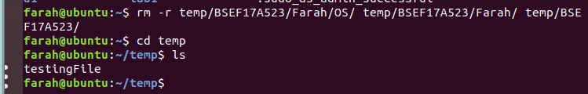

12-



13-



14-



15-



16-

“Man commandname” is the command to see complete details of a command on shell

17-



18-

Yes, we can use rm -r to remove directory which is not empty and rm -rf for directory associated with other directories and files.

1-

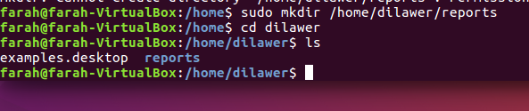

2-

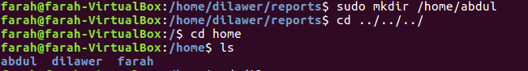

3-

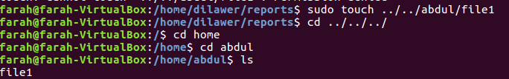

4-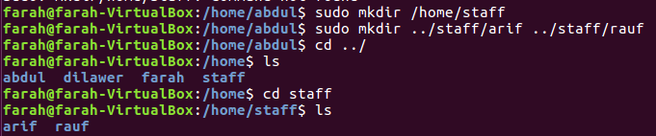

5-

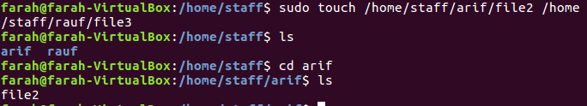

6-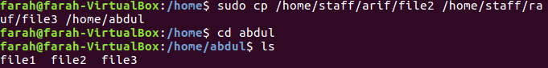

7-

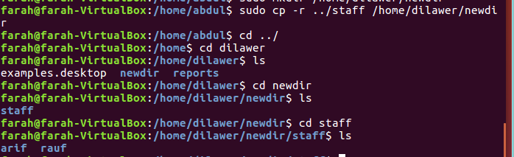

8-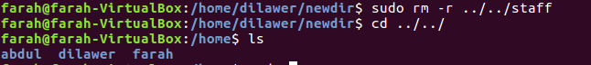

9-

